Bergen County Cooperative Library System

Request for Proposal

BCCLS Delivery System

Issued by: Cindy Czesak, Interim Executive Director
BCCLS - Bergen County Cooperative Library System
810 Main Street
Hackensack, NJ 07601
201-489-1904

Date issued: August 13, 2018

Due Date: September 5, 2018

SECTION 1 - INTRODUCTION …………………………………………………………….. 2
SECTION 2 - SCOPE OF WORK ………………………………………………………….. 3
SECTION 3 - SPECIAL TERMS AND CONDITIONS …………………………………… 6
SECTION 4 - VENDOR REQUIREMENTS/RESPONSIBILITY ..………………………. 9
SECTION 5 - QUALITY ASSURANCE AND ADMINISTRATIVE FEES ……………… 12
SECTION 6 - BIDDERS’ CONFERENCE AND QUESTIONS ………………………….. 13
SECTION 7- COST INFORMATION ..…………………………………………….....…….. 13
SECTION 8- RENEWAL FACTORS ……………………………………………………..... 14
SECTION 9- BIDDER SUBMITTAL REQUIREMENTS …………………………………. 15
SECTION 10- AWARD PROCESS ...…………………………………………………..….. 23
SECTION 11- BIDDER INSTRUCTIONS ………………………………………………..... 24
SECTION 12- SEALED PROPOSALS ...……………………………………………….…. 25

APPENDIX A- LIST OF DELIVERY SITES & STATISTICS……...…………….….……. 26
APPENDIX B- EXAMPLES OF DELIVERY LABELS/BINS …..………………..………. 27
APPENDIX C- PROPOSAL RESPONSE CHECKLIST……………………..………....... 28

REQUEST FOR PROPOSAL (RFP) SPECIFICATIONS
FOR CONSORTIUM-WIDE LIBRARY DELIVERY SYSTEM SERVING
THE BERGEN COUNTY COOPERATIVE LIBRARY SYSTEM

SECTION 1 - INTRODUCTION:

1.1 - BACKGROUND AND PURPOSE

The purpose of this Request for Proposal is to solicit proposals from qualified firms and organizations to provide delivery of library materials for the 77 public libraries that are members of the Bergen County Cooperative Library System hereafter referred to as “BCCLS.” BCCLS has 77 member libraries in 4 adjacent counties in Northern New Jersey. Bidders must meet the requirements as described within these RFP specifications. Pursuant to the express terms of this RFP, the contract will be awarded to the bidder whose proposal is most advantageous to BCCLS in accordance with the selection criteria described in this RFP. The successful bidder will provide the services required under this RFP as an independent contractor.

LibraryLinkNJ, the statewide library network, currently provides delivery service to BCCLS member libraries. BCCLS is looking to streamline and improve services for its public by contracting with its own vendor for the service.
When a library user desires materials and information from another BCCLS library, the user requests a loan through his/her local library’s online catalog. The requested materials are sent from the owning library to the user’s preferred local library through delivery. Library users may also return materials borrowed from other member libraries to any other BCCLS library, which then uses delivery to return the items to the owning library. Materials to be shipped include - but are not limited to - books, audiobooks, CDs, DVDs, video games, documents, envelopes, boxes of books and other library material.

Note: Supplies will be provided by BCCLS, such as plastic bags and tote bins.

1.2 - TERM OF CONTRACT

The contract for the BCCLS Delivery System, the delivery service specifically for BCCLS and its member libraries, shall be in effect from January 2, 2019 through December 31, 2019. BCCLS may extend the contract award for up to two additional “one-year” periods or parts thereof. The contract is held by BCCLS as an organization, rather than its individual members. All billing is sent to BCCLS. On or before the date which is thirty days prior to the contract expiration date, the vendor will be notified with regard to the decision to extend the contract award. If BCCLS requests an extension, the agreement of this extension will be in the form of a supplement to the contract award.

1.3 - SCHEDULE OF EVENTS
Release of RFP: | Monday, August 13, 2018
Bidders Conference (mandatory): online | Tuesday, August 21, 2018, online (https://biddersconference2018.eventbrite.com)  11:00 a.m.
RFP Proposal Due Date: | Wednesday, September 5, 2018 by 4:00 p.m.
Open and Read Proposals: | Thursday, September 6, 2018, 10:00 a.m.
Anticipated Announcement of Award: | Friday, October 26, 2018
Anticipated Contract Commencement Date: | Wednesday, January 2, 2019

SECTION 2 - SCOPE OF WORK:

2.1 - FREQUENCY

Each member library shall receive a delivery daily, Monday through Friday, during the library’s operating hours, on days the library is open. Libraries that have multiple locations (branches) will only receive delivery to their primary building. Delivery will also be made daily to the BCCLS office (location change anticipated winter 2019). This totals to 78 daily stops. A link to a detailed listing of libraries and addresses appears in Appendix A.

Stops for pickups and deliveries at the libraries will be on a route basis. It is preferable for delivery to be at a consistent time of day, with a set schedule of stops. All bidders are requested to include a proposed detailed schedule for the initial contract launch. We are willing to discuss mutually acceptable revisions that will contribute to efficient services to libraries.

BCCLS requests that interested vendors provide a proposal that includes cost per stop pricing for five days per week delivery options. Vendors may propose different or more efficient methods of providing alternative services including a detailed cost proposal.

Holidays: Each year, BCCLS will provide the vendor with a list of holidays when BCCLS will not expect delivery. Holidays will typically include: New Year’s Day, Martin Luther King Day, President’s Day, Good Friday, Memorial Day, Independence Day, Labor Day, Columbus Day, Veteran’s Day, Thanksgiving, the day after Thanksgiving, and Christmas Day. Other dates may vary from library to library and will be shared prior to the start of the year.

Although no deliveries take place on holidays, library patrons continue to request items online and the vendor must be prepared for an increase in volume after a holiday.

2.2 - DELIVERY VOLUME

The estimated number of total items transported from one library to another in 2017 was 2,564,298. This includes over 600,000 media items (DVDs, CDs, etc.), 240,000 smaller print items (board books, paperbacks, etc.), 140,000 picture books, 90,000 audio books, 10,000 magazines, as well as over 1.2 million other potentially larger printed items of various sizes (hardcovers, kits, graphic novels, etc.). The weekday delivery item averages are as follows:

 | Pickups |  | Drop-offs
 | Yearly Avg. | Summer/Peak | Yearly Avg. | Summer/Peak
Monday* | 17,317 | 21,062 | 9,034 | 12,288
Tuesday | 8,641 | 9,178 | 10,829 | 11,756
Wednesday | 7,789 | 9,979 | 11,912 | 14,231
Thursday | 7,121 | 9,050 | 11,350 | 13,810
Friday | 5,783 | 6,756 | 10,713 | 12,756
*Monday pickup includes all items marked for outgoing transit over the weekend. Friday drop-off includes any return transits that may have not been scanned in until the next day (Saturday). These daily numbers do not (and cannot) account for items marked for delivery later in the day after a library has already received their pickup for the day, although that offset may be distributed somewhat evenly.

The number of plastic totes picked up at each library will vary daily. A plastic tote bin can hold a minimum of approximately 20 items. However, this number varies widely based on item type/size. Totes will be labeled as either for one (1) library or as an assortment that needs sorting for delivery the next scheduled day. Inside each tote, items will be packaged in plastic “zip-top” bags labeled for their respective destinations. These bags may contain single or multiple items, but each bag will be for an individual library. (See Section 3.4 Packaging and Labeling Requirements)

The vendor will pick-up all materials awaiting pickup by each driver, each scheduled delivery day, and specify how this will be done. Vendor vehicles need to be of sufficient size and capacity to handle the volume of materials on a route, keeping in mind Mondays may have the heaviest volume.

2.3 - DELIVERY TIMES

- Deliveries are made Monday through Friday.
- Libraries prefer a fixed time for deliveries. The vendor will outline proposed schedules and give possible variations for variable routes.
- The vendor must schedule its delivery time during the hours a library is open. Most libraries are open for service from 10:00 a.m. to 5:00 p.m. or longer.
- Libraries with unique hours outside of the delivery hours as of the date hereof above are identified in Appendix A.
- Materials should not be delivered if the library is closed, unless the BCCLS office has confirmed an alternate arrangement. Re-delivery must be attempted the next time a stop is scheduled for that site. If the library is closed for five consecutive days, the materials must be delivered to the BCCLS office.
- The vendor must notify the BCCLS office by the close of the next business day of any missed stops and provide reason(s) for the occurrence.
2.4 - SORTING

A. Vendor will maintain at least one sorting facility. It is desirable that it be strategically located within or adjacent to the BCCLS service area to serve the geographic distribution of the service.
B. Ability to sort on the truck is highly desirable in order to provide same-day delivery for packages destined to a future stop on the same route, reducing the volume of items at the sorting facility.

2.5 - ADDITIONS AND DELETIONS

BCCLS may add and delete libraries or stops in the delivery schedule any time during the contract year. Appendix A is the current delivery list. Within 10 business days’ notification from BCCLS, the vendor shall make additions and deletions in the delivery schedule, and bill at the contract rates.

2.6 - CHANGES IN SERVICE

Changes by the vendor to the delivery schedule and service may be instituted only after notification to, discussion with, and written agreement from the BCCLS Executive Director. A five business day notification of the proposed change is required.

The impact of weather, such as a snowstorm or other emergencies, on a day’s route will be addressed on a case-by-case basis.

BCCLS will notify the vendor of weather-related closings. Although no deliveries may take place on days when a weather emergency curtails or cancels delivery, library patrons continue to request items online and the vendor must be prepared for an increase in volume after such an event. BCCLS will only pay for stops that are made.

2.7 - IMPROVEMENTS TO PROPOSED SCOPE OF WORK

Bidding vendors are encouraged to propose different methods of providing delivery service provided that proposed changes create demonstrably more efficient or cost effective delivery. We encourage vendors to make multiple proposals when alternatives are presented: one proposal for current level of service and additional proposals for new variations. See also Section 3.6 - Technology.

2.8 - TRANSITION PLAN

Bidding vendors will need to be willing to work immediately upon award of contract with the BCCLS Delivery Task Force to form a transition plan and timeline for a changeover from the current vendor.

SECTION 3 - SPECIAL TERMS AND CONDITIONS:

3.1 - INDEPENDENT CONTRACTOR

The successful bidder, along with its employees and/or contractors will be considered an independent contractor and shall not be deemed to be an agent, servant, employee or representative of BCCLS. In seeking an independent contractor to perform the services required under this RFP, BCCLS recognizes that no one organizational structure is necessary to achieve independent contractor status. Rather, BCCLS understands that a vendor may achieve independent contractor status through a variety of organizational structures.

3.2 - BILLING

Vendor will bill BCCLS monthly, net 30 days, for the previous month’s service. Vendor is responsible to keep records of all stops and exceptions and bill accurately. The bill must indicate clearly the number of stops made at each frequency and rate. Any credits will detail all exceptions to scheduled work and include the date, name of library and reason for the credit. BCCLS pays bills monthly (NET-30 terms).

3.3 - MATERIALS

Materials to be shipped include, but are not limited to: books, audiobooks, CDs, DVDs, video games, documents, envelopes, boxes of books, and other library material.

BCCLS does NOT allow libraries to send the following materials through the delivery system:

- Oversized/heavy packages: individual packages that weigh more than 50 pounds or that exceed more than 130 inches in length, plus width, plus height of the longest side.
- Fragile/breakable items.
- Equipment.
- Furniture.
- Material of a rare or irreplaceable nature.
- Cash.
- Postal items.

The vendor will notify BCCLS in a timely manner about violations or questions.

3.4 - PACKAGING AND LABELING REQUIREMENTS

Each participating library is responsible for packaging and labeling.

Participating libraries shall securely package items to be delivered. Individual item(s) will be placed in tote bins to be sorted by the vendor. Multiple items intended for the same destination may be placed in a single “zip-top” bag, of 12 inches by 12 inches by 4 inches. A larger plastic bag (a sealed bag, but not “zip-top”, of 14 inches by 20 inches secured with rubber bands) is also used. Bubble wrap is used when needed. No other special packaging is required.

BCCLS will provide plastic bags, hinged-lid tote bins and other packaging materials for libraries to use to facilitate the transport of materials. These tote bins are approximately 17 inches top length, 12 inches top width, 11 inches depth. The vendor will monitor the quantity of empty delivery totes on hand and inform BCCLS when the possibility of resupply is necessary.

Libraries shall include an appropriate delivery label with each item or package shipped. The label contains the name and address of the ship-to library and the ship date of the next expected delivery pick-up. The label contains a unique identification number for each library as developed and assigned by the current vendor. Sample labels are provided in Appendix B.

A bidder may retain the current structure or propose a different structure for consideration by the BCCLS Delivery Task Force.

3.5 - RECORD KEEPING AND DOCUMENTATION

Except in the case of one-time shipments, libraries do NOT manifest or track individual items or shipments. The vendor, in turn, moves shipments intact to the destination address and will not have records or knowledge of what is contained in each individual shipment.

Libraries record the total number of pieces (packages) picked up at a library each delivery day. Drivers must sign a log that the library maintains in a visible, permanent location. Drivers will sign only on the day the actual delivery takes place. This log is each library’s delivery record and is required by BCCLS. It documents monthly delivery activity. A bidder may retain the current structure or propose a different structure for consideration by the BCCLS Delivery Task Force to document each delivery and all exceptions, when applicable.

The vendor shall keep a full and accurate record of all expenses associated with delivery, including, but not limited to, personnel, vehicles (purchase/lease, maintenance/repairs, fuel, etc.), rent, profit and overhead, and other costs. The vendor shall make such records available to BCCLS semi-annually.

3.6 - TECHNOLOGY

The vendor will provide and describe any technology used to facilitate delivery including, but not limited to, the following:

- Record keeping.
- Monitoring of route/driver status.
- Notification of delivery/pick-up completion at each stop.
- Online communication between BCCLS and the vendor.
- Problem resolution.
- Customer-service management system.
- Options that save communications time and assist in route efficiency.

The vendor must document the option included in the price per stop quote and break out pricing for technology options.

3.7 - SUBCONTRACTING OR ASSIGNMENT
- Subcontracting: If the vendor anticipates relying on subcontractors to fulfill the service outlined by this RFP, the vendor’s response must identify all anticipated subcontractors. Except as set forth in the vendor’s proposal, the vendor may not subcontract without prior written consent of BCCLS in its sole discretion. Such consent, if granted, shall not relieve the vendor of any of its responsibilities under the contract, nor shall it create privity of contract between BCCLS and any subcontractor. If the vendor uses a subcontractor to fulfill any of its obligations, the vendor shall be responsible for the subcontractor’s: (i) performance, (ii) compliance with all of the terms and conditions of the contract, and (iii) compliance with the requirements of all applicable laws. If BCCLS consents to the use of subcontractors, the successful vendor is required to provide a copy of any subcontractor agreement as an appendix to the contract between BCCLS and the successful vendor.
- Assignment: The vendor may not assign its responsibilities under the contract, in whole or in part, without the prior written consent of BCCLS in its sole discretion.

3.8 - NO CONTRACTUAL RELATIONSHIP BETWEEN SUBCONTRACTORS AND BCCLS

Nothing contained in any of the contract documents, including this RFP and the vendor’s proposal shall be construed as creating any contractual relationship between any subcontractor and BCCLS.

SECTION 4 - VENDOR REQUIREMENTS/RESPONSIBILITY:

The Vendor agrees to the following:

A. To perform all of the services listed in the proposal specifications in the sections above as an independent contractor.
B. To purchase and maintain, without lapse, insurance written by a responsible insurance company, including the following coverage in the event of loss:

1. Workers’ Compensation of $1,000,000 per accident and Employer’s Liability on employees and independent contractors.
2. Cargo Insurance up to $100,000 per shipment.
3. Warehouse insurance to cover any potential loss from fire, flood, etc.
4. Commercial General Liability Insurance written on an occurrence form, including independent contractor liability, contractual liability, covering but not limited to bodily injury liability, property damage liability and the liability assumed under the indemnification provisions of this contract. The minimum limits of liability shall not be less than a combined single limit of One Million Dollars ($1,000,000.00) per occurrence and Two Million Dollars ($2,000,000.00) general aggregate.
5. Documentation of each of these must be filed with BCCLS with the submitted proposal. If awarded the contract, the vendor must provide BCCLS with certificates of insurance evidencing that BCCLS is named as an additional insured on all liability policies. Notice of cancellation/change of coverage must be provided.
6. The bidder is encouraged to document if his/her firm has higher liability coverage.
7. Vendor is asked to represent the number of motor vehicle accidents in the past two years and the damages received or paid.

C. To assume all risk of loss and to indemnify and hold harmless BCCLS, its Executive Board, individual libraries, agents and employees from and against any liabilities, demands, claims suits, losses, damages, causes of action fines or judgments, including costs, attorney and witness fees, and expenses incident thereto, for injuries to persons (including death) and for the loss of damage to, or destruction of property arising out of or in connection with this agreement, and the acts or omissions of vendor’s employees, agents, and subcontractors, unless caused by the negligence or willful misconduct of BCCLS, its officers, agents or employees.

D. To be liable for any expense incurred as a consequence of any motor vehicle infraction or parking violations attributable to employees and/or subcontractors of the vendor.

E. That under no circumstances is the vendor or any subcontractor’s personnel deemed an employee of BCCLS. Vendor or subcontractor personnel shall not represent themselves to be employees of BCCLS.

F. That under no circumstances shall BCCLS be held liable for any acts by and/or claims brought against any of the vendor’s employees or agents whether committed inside or outside the scope of employment.

G. To assume all responsibility for its actions, its employee actions and, if any, subcontractor's actions while engaged in any activity connected with the contract resulting from this RFP.

H. To make a reasonable attempt to locate missing or lost materials in the delivery system and have an established procedure for dealing with missing/lost items.

I. To provide a dedicated contact person(s) who is on-duty and accessible by telephone and email Monday through Friday during the hours 9:00 a.m. - 5:00 p.m. to resolve problems reported by individual libraries or the BCCLS office and to contact drivers by radio or cell phone when necessary. The vendor will acknowledge and respond to questions and feedback from individual libraries or the BCCLS office within one hour of receipt.

J. Drivers must speak, read and write English sufficient for basic communication with the vendor’s dispatch staff and staff at libraries. The vendor is responsible for clearly communicating customer needs to drivers, including communicating with those whose first language is not English.

K. To bill BCCLS for pick-ups or deliveries from/to stops on the master list only. Payments for other pick-ups or deliveries must be authorized in writing by BCCLS.

L. To communicate directly with individual libraries. All communication concerning missed pick-ups, scheduled stops, packaging and labeling, requests for pick-ups outside the contracted schedule and other delivery issues must be between the client and vendor.

M. To ensure that vendor personnel have the ability to lift up to 50 lbs. and to perform the bending, stooping and lifting actions required for the delivery functions of this service.

N. To ensure that vendor personnel are in attire clearly indicating the name of the firm and their affiliation with the firm. Personnel will have company identification displayed at all times and must maintain a neat and orderly appearance.

O. To ensure that drivers have sufficient equipment (e.g. hand trucks, boxes, bins) to pick up all waiting items and to transport them to their vehicle.

P. That the vehicles must be supplied by the vendor or any subcontractors and maintained in a clean condition and in good working order and covered by the vendor’s liability and loss/damage insurance policies in relation to the services provided to BCCLS.

Q. To supply a detailed daily schedule for each route with descriptions of the type of delivery vehicle that will be used on each route. New routes and vehicle descriptions shall be supplied to BCCLS and are subject to approval by BCCLS.

R. All vehicles shall be of sufficient size and capacity to handle the volume of materials on a particular route and to accommodate changes in volume throughout the year.

S. That the vendor will supply a list, with addresses and descriptions (including the location, quantity and sorting/storage area in square feet), of all depots and sorting facilities. Locations must be of a sufficient size to serve the volume.

T. That the vendor will meet with the BCCLS Delivery Task Force quarterly, either face-to-face at the BCCLS office, at the vendor’s warehouse, by telephone conference call, or online meeting to discuss the status of delivery and work with BCCLS staff to promptly resolve problems.

U. At the request of BCCLS, the vendor will meet with the BCCLS Delivery Task Force for scheduled sort site inspections.

V. In the event contractual obligations are not being met, BCCLS shall present in writing to the vendor a list of all material concerns. The vendor shall have 30 days to remedy the concerns. If the concerns are not addressed within 30 days, BCCLS shall have the right, in its sole discretion, to renegotiate or terminate the contract with 90 days’ written notice to the vendor with no penalty to BCCLS or recourse to the vendor.

W. Both BCCLS and the vendor shall have the right to renegotiate or terminate the contract with 180 days’ written notice to the other party without cause.
X. Vendor may be held liable (at typical library replacement costs) for all theft, losses, and damages incurred while in vendor’s possession or a subcontractor’s possession.

SECTION 5 - QUALITY ASSURANCE AND ADMINISTRATIVE FEES:

In assuming this work, the vendor agrees to provide high quality services in all respects, and BCCLS reserves the right to charge administrative fees when quality work is lacking in specific situations, that is:

A. The vendor shall track each stop made and bill for all complete stops made during each month.

B. For any incomplete stops, i.e., when all materials available for delivery are not picked up, the vendor or the library will notify the BCCLS office of the date and library name, and the vendor will incur an administrative fee equal to 25% of the per stop cost for that stop. The vendor shall automatically subtract this administrative fee from the monthly invoice. (Not applicable the day after holidays or the day after a weather emergency that curtails delivery services.)

C. It is the vendor’s responsibility to bill accurately. When stops that are not made or are incomplete are billed as complete, and this fact is discovered by BCCLS, a $50.00 administrative fee will be deducted from the month’s payment for each affected stop. This amount is in addition to the total stop cost in the event of a missed stop and in addition to the 25% administrative fee, in the event of an incomplete stop. More than two repeated months of inaccurate billing will be considered breach of contract.

D. The BCCLS Delivery Task Force will periodically verify turnaround time, sorting accuracy, and delivery accuracy by sampling stops. Should the agreed upon standards for turnaround time and sorting accuracy be lacking, the vendor will be given seven days’ notice to correct the problem. If either one of these standards is still deficient in a subsequent sample, a 1% administrative fee will be deducted from the next month’s invoice. More than two repeated months of non-compliant turnaround time and/or sorting accuracy will be considered breach of contract.

E. The vendor shall provide high quality responsive customer service by telephone and/or email during the normal work week (9:00 a.m. – 5:00 p.m.) and respond to requests from the individual libraries within one hour (a carbon copy of the communication will be kept on file at the BCCLS Office). Failure to respond in a timely manner consistently will be considered breach of contract.

Standards:

The vendor will provide:

A. The vendor will provide a maximum of one business day transit time between shipping library and destination library for 80% of items. The vendor will provide a maximum of three business days’ transit time for 100% of items. This will be measured by sampling by BCCLS and problem resolution with delivery libraries. The vendor will ensure this through timely sorting, adequate storage, and efficient transfer of materials and provide an explanation of how they will ensure this.

B. A minimum of 99% sorting accuracy.

C. A minimum of 99% delivery accuracy.

D. Response to customer service requests by telephone and email within one hour during the normal work week (9:00 a.m. – 5:00 p.m.).

SECTION 6 - BIDDERS’ CONFERENCE AND QUESTIONS:

All prospective bidders must attend a Bidders’ Conference on Tuesday, August 21 at 11:00 a.m. via Adobe Connect Webinar.

· Attendance is mandatory by joining the webinar.
· Advance registration is required; see https://biddersconference2018.eventbrite.com for registration information.
· Webinar connection instructions:
Adobe Connect Link: http://bccls.adobeconnect.com/deliveryrfp082118/
Please utilize guest login and clearly identify your name and company in the username.
Audio & chat conferencing available via browser or Adobe Connect app (iOS/Android).

Bidders may submit written questions (citing the particular proposal sections and paragraph number, where appropriate) no later than August 19, 2018 at 11:00 a.m.. See https://biddersconference2018.eventbrite.com to submit questions and register for the conference. Answers to all properly submitted questions will be provided at the meeting on August 21, 2018.

SECTION 7 - RENEWAL FACTORS:

A. Provided sufficient funding is available, at the sole discretion of BCCLS, BCCLS may offer an annual contract renewal, with a maximum of up to two additional one-year renewals.

B. Volume fluctuations may occur during the contract period as the parties negotiate one of the renewals available in the contract. Please describe how these will affect pricing at renewal time. For example, if volume increases or decreases by five percent, in terms of packages shipped, how will that affect the renewal price? BCCLS regularly gathers statistics from the libraries and anticipates that these annual figures will be used to measure volume fluctuations, except when the vendor proposes a mutually acceptable alternative.

C. Regulatory change in the industry may increase or decrease vendor costs at renewal time. BCCLS understands that such costs, e.g., minimum wage increases or fluctuations in fuel charges, may affect the vendor’s cost of doing business. BCCLS prefers to accept direct increases due to regulation and direct decreases, in such an event. However, BCCLS will not include any overhead or profit in such cases.

D. Please provide renewal costs for possible renewal should BCCLS exercise the renewal option after the first contract year.

E. Please provide renewal costs for possible renewal should BCCLS exercise the renewal option after the second contract year.

SECTION 8 - COST INFORMATION:

The vendor must show all costs for the proposed service. Any costs not included in this proposal, for any equipment, personnel, software or service necessary to implement the service will be the responsibility of the vendor. Prices are for BCCLS delivery as described in this document. See Appendix A for a link to statistical information about delivery volume and locations.

Vendor shall quote prices for:

- Cost per stop for all delivery stops.
- The vendor may quote a specific range of costs/stop. If the vendor quotes a specific range of costs/stop to account for geographic and volume differences, the vendor must state a minimum total anticipated from a contract award.
- Cost per stop for five days per week delivery.
- Cost per stop for one time delivery/pick-up.
- Costs per stop to add stops.
- If your bid includes a fuel surcharge, please include the following information in your proposal to demonstrate that the surcharge is affecting only fuel costs and not the overall contract:

- Detailed route information with daily mileage and fuel efficiency for all vehicles, to allow BCCLS to verify that fuel surcharges are not applied to sorting effort and driver hourly compensation.
- Baseline fuel cost at time of proposal.
- Source of data for fuel cost increases/decreases.
- Fuel cost credits must be included, in the event that fuel costs decrease.

SECTION 9 - BIDDER SUBMITTAL REQUIREMENTS:

In addition to answers to Section 8 - Cost Information, each bidder shall submit responses to all of the following information in the order listed below:

Identify responses by number and letter. (e.g. 2, 4-A, 5-B-3, etc.)

- Name of a single individual that will be assigned as the project manager of this project. Please include title or position, telephone number(s) and email address.
- Describe your firm’s experience with library delivery and/or similar work.
- Service Plan describing how the vendor proposes to administer and support the delivery to libraries: (Described in Section 2 and in Section 3)

A. Frequency
1. The bidder will include a detailed schedule of stops for the initial contract launch.
2. The bidder will detail how they will provide service to libraries open on holidays.
3. The bidder will describe how they will be prepared for an increase in volume after library closings for holidays or weather emergencies.
B. Delivery Volume
1. The bidder will describe how they will pick up all materials awaiting pick-up by each driver, each scheduled delivery day, and specify how this will be done.
C. Delivery Times
1. The bidder will describe how they will fulfill the following transit times:
a. One business day transit time, 80% of the time
b. Three business day transit time, 100% of the time
2. Libraries prefer fixed times for deliveries. The bidder will outline proposed schedules and give possible variations for variable routes.
D. Additions and Deletions
1. The bidder agrees that BCCLS may add or delete stops with 10 business days’ notification.
E. Changes in Service
1. The vendor agrees that changes to the delivery schedule may be instituted only after notification to, discussion with, and written agreement from BCCLS. A five business day written notification to BCCLS of the proposed change is required.

F. Improvements to the Current Scope of Work
1. The bidder may propose new, different or more efficient methods of providing this service. We encourage vendors to make multiple proposals when alternatives are presented -- one proposal for the current level of service and additional proposals for new variations. See also section 3.6 - Technology.
G. Transition Plan
1. The vendor will describe a transition plan and timeline for a changeover from the current vendor. Include details at the library level (packaging, labeling, sorting, etc.). The vendor agrees to work with the BCCLS Delivery Task Force to approve the plan.
H. Independent Contractor
1. The bidder, along with its employees and/or contractors will be considered an independent contractor and shall not be deemed to be an agent, servant, employee or representative of BCCLS.
I. Billing
1. The bidder will bill BCCLS monthly, net 30 days.
J. Materials
1. The bidder agrees with the descriptions of materials to be shipped and exclusions described in Section 3.3.
K. Packaging and labeling requirements
1. The bidder will include a description of any vendor-required packaging and delivery procedures that are different from those described in Section 3.4.
L. Record Keeping and Documentation
1. The bidder agrees that drivers must record the total number of packages picked up at a library each delivery day. Additionally, drivers must sign a log that the library maintains in a visible, permanent location. Drivers will sign only on the day the actual delivery takes place.
2. A bidder may retain the current structure or propose a different structure, for consideration by the BCCLS Delivery Task Force, to document each delivery and all exceptions, when applicable.
M. Technology
The bidder will provide and describe available technology in these areas for the following processes:

1. Record keeping
2. Monitoring route/driver status
3. Notification of delivery/pick-up completion at each stop
4. Online communication between BCCLS and bidder
5. Problem resolution
6. Customer-service management system
7. Include a description of technology options with break out pricing in the areas described in 3.6

N. Subcontracting or Assignment
1. Except as described in the bidder’s proposal, the bidder may not subcontract without prior written consent of BCCLS in its sole discretion. Such consent, if granted, shall not relieve the vendor of any of its responsibilities under the contract, nor shall it create privity of contract between BCCLS and any subcontractor. If the vendor uses a subcontractor to fulfill any of its obligations, the bidder shall be responsible for the subcontractor’s: (i) performance; (ii) compliance with all of the terms and conditions of the contract; and (iii) compliance with the requirements of all applicable laws.
2. The bidder may not assign its responsibilities under the contract, in whole or in part, without the prior written consent of BCCLS in its sole discretion.
O. No Contractual Relationship Between Subcontractors and BCCLS
1. Nothing contained in any of the contract documents, including this RFP and the bidder’s proposal, shall be construed as creating any contractual relationship between any subcontractor and BCCLS.

4. Provide the following information for each subcontractor that the vendor intends to utilize in connection with the contract: (Described in Section 3)

A. Name of subcontractor, if known at time of RFP response (the final contract will require detailed information on any proposed subcontractor).
B. Address and telephone number for subcontractor if known at time of RFP response (the final contract will require detailed information on any proposed subcontractor).
C. Services for which vendor plans to utilize subcontractor.

If a vendor intends to subcontract a portion or portions of the contract, but is unable to provide the above information for each subcontractor at the time that vendor submits its proposal, the vendor must provide a detailed plan of how the vendor plans to provide the services required under the contract and the steps that the vendor will take to timely procure subcontractors to provide those services.

If a vendor does not intend to utilize any subcontractor in connection with the contract, the vendor should indicate that the vendor does not intend to utilize any subcontractor.

5. Bidder Requirements/Responsibility: (Described in Section 4)

The bidder agrees to the following and provides documentation where necessary:

A. To perform all of the services listed in the proposal specifications as an independent contractor.
B. To purchase and maintain, without lapse, insurance written by a responsible insurance company, including the following coverage in the event of loss:

1. Workers’ Compensation of $1,000,000 per accident and Employer’s Liability on employees and independent contractors.
2. Cargo Insurance up to $100,000 per shipment.
3. Warehouse insurance to cover any potential loss from fire, flood, etc.
4. Commercial General Liability Insurance written on an occurrence form, including independent contractor liability, contractual liability, covering but not limited to bodily injury liability, property damage liability and the liability assumed under the indemnification provisions of this contract. The minimum limits of liability shall not be less than a combined single limit of One Million Dollars ($1,000,000.00) per occurrence and Two Million Dollars ($2,000,000.00) general aggregate.
5. Documentation of each of these must be filed with BCCLS with the submitted proposal. If awarded the contract, the vendor must provide BCCLS with certificates of insurance evidencing that BCCLS is named as an additional insured on all liability policies. Notice of cancellation/change of coverage must be provided.
6. The bidder is encouraged to document if his/her firm has higher liability coverage.
7. Vendor is asked to represent the number of motor vehicle accidents in the past two years and the damages received or paid.

C. To assume all risk of loss and to indemnify and hold harmless BCCLS, its Executive Board, individual libraries, agents and employees from and against any liabilities, demands, claims suits, losses, damages, causes of action fines or judgments, including costs, attorney and witness fees, and expenses incident thereto, for injuries to persons (including death) and for the loss of damage to, or destruction of property arising out of or in connection with this agreement, and the acts or omissions of vendor’s employees, agents, and subcontractors, unless caused by the negligence or willful misconduct of BCCLS, its officers, agents or employees.

D. To be liable for any expense incurred as a consequence of any motor vehicle infraction or parking violations attributable to employees and/or subcontractors of the vendor.

E. That under no circumstances is the vendor or any subcontractor’s personnel deemed an employee of BCCLS. Vendor or subcontractor personnel shall not represent themselves to be employees of BCCLS.

F. That under no circumstances shall BCCLS be held liable for any acts by and/or claims brought against any of vendor’s employees or agents whether committed inside or outside the scope of employment.

G. To assume all responsibility for its actions, its employee actions and, if any, subcontractor’s actions while engaged in any activity connected with the contract resulting from this RFP.

H. To make a reasonable attempt to locate missing or lost materials in the delivery system and have an established procedure for dealing with missing/lost items.

I. To provide a dedicated contact person(s) who is on-duty and accessible by telephone and email Monday through Friday during the hours 9:00 a.m. – 5:00 p.m. to resolve problems reported by individual libraries or the BCCLS office and to contact drivers by radio or cell phone when necessary. The vendor will acknowledge and respond to questions and feedback from individual libraries or the BCCLS office within one hour of receipt.

J. Drivers must speak, read and write English sufficient for basic communication with the vendor’s dispatch staff and staff at libraries. The vendor is responsible for clearly communicating customer needs to drivers, including communicating with those whose first language is not English.

K. To bill BCCLS for pick-ups or deliveries from/to stops on the master list only. Payments for other pick-ups or deliveries must be authorized in writing by BCCLS.

L. To communicate directly with individual libraries. All communication concerning missed pick-ups, scheduled stops, packaging and labeling, requests for pick-ups outside the contracted schedule and other delivery issues must be between the client and vendor.

M. To ensure that vendor personnel have the ability to lift up to 50 lbs. and to perform the bending, stooping and lifting actions required for the delivery functions of this service.

N. To ensure that vendor personnel are in attire clearly indicating the name of the firm and their affiliation with the firm. Personnel will have company identification displayed at all times and maintain a neat and orderly appearance.

O. To ensure that drivers have sufficient equipment (e.g. hand trucks, boxes, bins) to pick up all waiting items and to transport them to their vehicle.

P. That the vehicles must be supplied by the vendor or any subcontractors and maintained in a clean condition and in good working order and covered by the vendor’s liability and loss/damage insurance policies in relation to the services provided to BCCLS.

Q. To supply a detailed daily schedule for each route with descriptions of the type of delivery vehicle that will be used on each route. New routes and vehicle descriptions shall be supplied to BCCLS and are subject to approval by BCCLS.

R. All vehicles shall be of sufficient size and capacity to handle the volume of materials on a particular route and to accommodate changes in volume throughout the year. BCCLS may seek to adhere a custom logo to the vehicles (vinyl wrap, magnet, etc.).

S. That the vendor will supply a list, with addresses and descriptions (including the location, quantity and sorting/storage area in square feet), of all depots and sorting facilities. Locations must be of a sufficient size to serve the volume.

T. That the vendor will meet with the BCCLS Delivery Task Force quarterly, either face-to-face at the BCCLS office, at the vendor’s warehouse, by telephone conference call, or online meeting to discuss the status of delivery and work with BCCLS staff to promptly resolve problems.

U. At the request of BCCLS, the vendor will meet with the BCCLS Delivery Task Force for scheduled sort site inspections.

V. In the event contractual obligations are not being met, BCCLS shall present in writing to the vendor a list of all material concerns. The vendor shall have 30 days to remedy the concerns. If the concerns are not addressed within 30 days, BCCLS shall have the right, in its sole discretion, to renegotiate or terminate the contract with 90 days’ written notice to the vendor with no penalty to BCCLS or recourse to the vendor.

W. Both BCCLS and the vendor shall have the right to renegotiate or terminate the contract with 180 days’ written notice to the other party without cause.

X. Vendor may be held liable (at typical library replacement costs) for all theft, losses, and damages incurred while in vendor’s possession or a subcontractor’s possession.

6. Detailed Schedule for all Routes with Libraries on Each Route: (Described in Section 4-Q and in Section 4-R)
A. Description of the type, size and capacity of the vehicles used for delivery by the vendor and/or subcontractors.

7. List, with Addresses and Descriptions: (Described in Section 4-S)
A. Location, quantity, and storage area, and which libraries are or will be serviced of a depot/sorting facilities used by the vendor.

8. Quality Assurance and Administrative Fees (Described in Section 5)

The Bidder agrees to provide high quality services in all respects and agrees that BCCLS reserves the right to charge administrative fees when quality work is lacking in specific situations, that is:

A. The vendor shall track each stop made and bill for all complete stops made during each month.
B. For any incomplete stops, i.e., when all materials available for delivery are not picked up, the vendor or library will notify the BCCLS office of the date and library name, and the vendor will incur an administrative fee equal to 25% of the per stop cost for that stop. The vendor shall automatically subtract this administrative fee from the monthly invoice. (Not applicable the day after holidays or the day after a weather emergency that curtails delivery services.)
C. It is the vendor’s responsibility to bill accurately. When stops that are not made or are incomplete are billed as complete, and this fact is discovered by BCCLS, a $50.00 administrative fee will be deducted from the month’s payment for each affected stop. This amount is in addition to the total stop cost in the event of a missed stop and in addition to the 25% administrative fee, in the event of an incomplete stop. More than two repeated months of inaccurate billing will be considered breach of contract.
D. The BCCLS Delivery Task Force will periodically verify turnaround time, sorting accuracy, and delivery accuracy by sampling stops. Should the agreed upon standards for turnaround time and sorting accuracy be lacking, the vendor will be given seven days’ notice to correct the problem. If either one of these standards is still deficient in a subsequent sample, a 1% administrative fee will be deducted from the next month’s invoice. More than two repeated months of non-compliant turnaround time and/or sorting accuracy will be considered breach of contract.
E. The vendor shall provide high quality responsive customer service by telephone and/or email during the normal work week (9:00 a.m. – 5:00 p.m.) and respond to requests from the individual libraries within one hour (a carbon copy of the communication will be kept on file at the BCCLS Office). Failure to respond in a timely manner on consistently will be considered breach of contract.
F. Standards:

The vendor will provide:

1. A maximum of one business day transit time between shipping library and destination library for 80% of items. The vendor will provide a maximum of three business days’ transit time for 100% of items. This will be measured by sampling by BCCLS and problem resolution with delivery libraries. The vendor will ensure this through timely sorting, adequate storage, and efficient transfer of materials and provide an explanation of how they will ensure this.
2. A minimum of 99% sorting accuracy.
3. A minimum of 99% delivery accuracy.
4. Response to customer service requests by telephone and email within one hour during the normal work week (9:00 a.m. – 5:00 p.m.).

9. Proof that the company is financially and logistically able to handle the delivery of large quantities of materials to many locations throughout BCCLS. (Described in Section 4-B)

- Bidders must supply proof of the company’s financial stability. Proof can be in the form of their most recent financial statement of the last fiscal year, a Dun & Bradstreet report, or another document/report from a reputable source of financial information. Proof of adequate insurance must be provided.

10. Customers for Reference

A. Please provide a list of current clients with contracts similar in size and scope that your company has contracted with in the last three years.

Information should include the following:
1. Organization Name and Address.
2. List the past/present contact(s) name, telephone number(s), and email.
3. Dollar volumes of the contracts on a yearly basis.
4. Size of the account and volume of transactions.
5. Detailed, itemized list of all services.
6. Length of time that the organization has been a client.

BCCLS is authorized to contact all references provided.

11. Terminations and defaults
A. If the bidder has had a contract terminated for default during the past five years, please give all details and particulars.
B. If the bidder has experienced no terminations for default in the past five years, please so declare.

12. History of Your Company

13. Organization Chart within Your Company

If the company is a subsidiary of another company, the corporate organizational chart must be provided along with an address for each unit.

14. Signed Proposal - An authorized official must sign the bid proposal

The proposal must also provide the name, title, address and telephone number of individuals with authority to bind the company and of those who may be contacted to clarify the information provided. Only signed proposals are eligible for review and consideration.

A completed copy of the Proposal Response Checklist must accompany the proposal. The checklist is available in Appendix C.

SECTION 10 - AWARD PROCESS:

10.1 - EVALUATION

Proposals will be evaluated for completeness and compliance with the requirements of the RFP by the members of the BCCLS Delivery Task Force which consists of ten directors of BCCLS member libraries and two BCCLS office staff.

a. Those proposals which are incomplete, which do not meet all requirements of the RFP, or otherwise deemed by the BCCLS Delivery Task Force to be non-responsive, will be rejected.

b. Proposals considered complete and responsive will be evaluated to determine if they comply with the administrative, contractual, and technical requirements of the RFP. If the proposal is unclear, bidders may be asked to provide written clarification at the sole discretion of the BCCLS Delivery Task Force.

c. Although the selection criteria to be used for final evaluation has been provided, it is not intended to limit imagination or creativity in preparing a proposal that will accomplish the same goals and expectations.

d. The final contract award will be based on a firm proposal that is most advantageous to BCCLS, price and other factors considered.

e. The BCCLS Delivery Task Force reserves the right not to accept any bid if proposals are unsatisfactory.

f. The BCCLS Delivery Task Force reserves the right to reject all proposals if it is unable to secure funding necessary to provide delivery service for a full year.

10.2 - SELECTION CRITERIA

The BCCLS Delivery Task Force will evaluate each responsive proposal received, rating each based on the selection criteria of price, experience, proposed service, references, and supporting documentation.

Proposals will be rated based on how well responses correspond with BCCLS’ needs. Some questions will be weighted more heavily than others to reflect their importance to the delivery program.

10.3 - AWARD PROCESS

a. The BCCLS Delivery Task Force will open and review each proposal on the basis of the selection criteria outlined above. It will make a recommendation to the BCCLS Executive Board. The BCCLS Executive Board will review the recommendation and incorporate the recommended proposal into the organization’s 2019 budget. The budget will be presented to the full membership in September and voted on in October.

b. Upon approval of the 2019 budget, including allocating funds for delivery, the BCCLS Executive Board and Executive Director will commence award notice and contract process as follows:

● Notify the successful vendor in writing of its winning proposal.
● Draw up a contract which will include by reference this RFP, the vendor’s proposal, and any additional contractual language as may be required by BCCLS or by law.
● Notify all other proposers in writing after a contract has been negotiated and signed with the successful vendor.
● Notify the BCCLS membership.

SECTION 11 - BIDDER INSTRUCTIONS:

11.1 - RFP SCHEDULE

See Section 1.3

11.2 - PROPOSAL PROCESS

a. Four paper copies of the vendor’s proposal must be received by 4:00 p.m. on Wednesday, September 5, 2018. In addition, the vendor must send an electronic copy of the proposal by the same deadline. Send to Cindy Czesak at cindy@bccls.org.

Proposals not submitted by the time and in the manner specified will not be evaluated.

b. Paper copies of the proposals must be delivered to:

Cindy Czesak, Interim Executive Director
Bergen County Cooperative Library System
810 Main Street
Hackensack, NJ 07601
Phone: 201-489-1904

c. BCCLS reserves the right to schedule an inspection of the vendor’s facilities.

d. This Request for Proposal and the selected vendor’s proposal shall become part of the formal contract between BCCLS and the vendor.

e. BCCLS reserves the right to accept any proposal in whole or in part or to reject any or all proposals if they do not meet the requirements specified in the Request for Proposal, the cost benefit desired, or if there is doubt about the vendor’s ability to perform the service.

SECTION 12 - SEALED PROPOSALS:

Proposals must be submitted in a SEALED envelope or carton, clearly marked with “RFP - BCCLS Delivery System,” the RFP Due Date and the name and address of the bidder. Any material not so marked may be opened as general mail, and may result in invalidating the bidder’s submission. Proposals may be mailed or delivered in person to the address above. Sealed proposals will be stamped and initialed by BCCLS office staff to indicate the applicable delivery time and date. Sealed proposals will be opened and read on Thursday, September 6, 2018 at 10:00 a.m. at the BCCLS office located at 810 Main Street, Hackensack, NJ 07601.

APPENDIX A - LIST OF DELIVERY SITES & STATISTICS:

● To view the Master File as a pdf, go to: https://goo.gl/unZcxf

● To view the Master File in Excel, go to: https://goo.gl/zNPqUf

Routes and stops subject to change upon review and re-optimization with vendor.
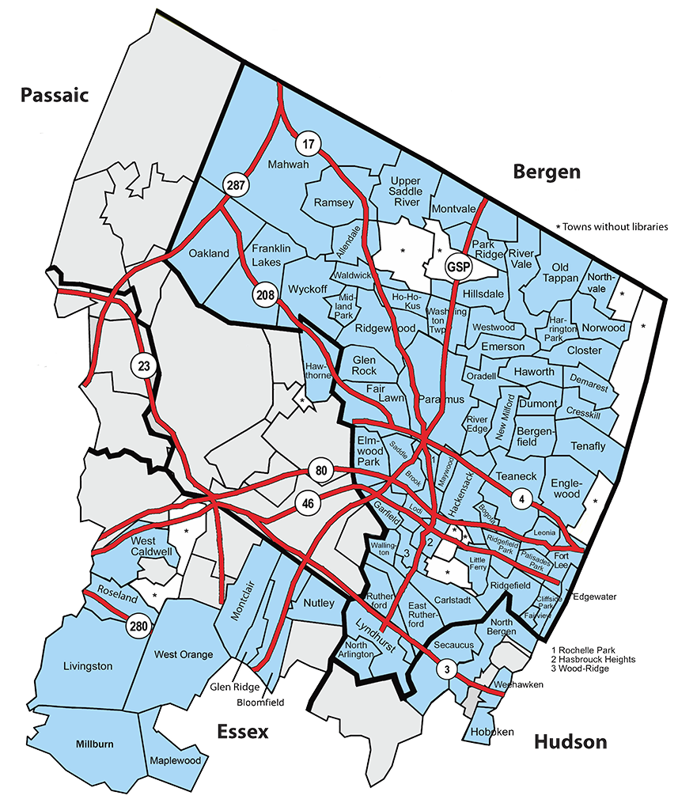
APPENDIX B - EXAMPLES OF DELIVERY LABELS/BINS:

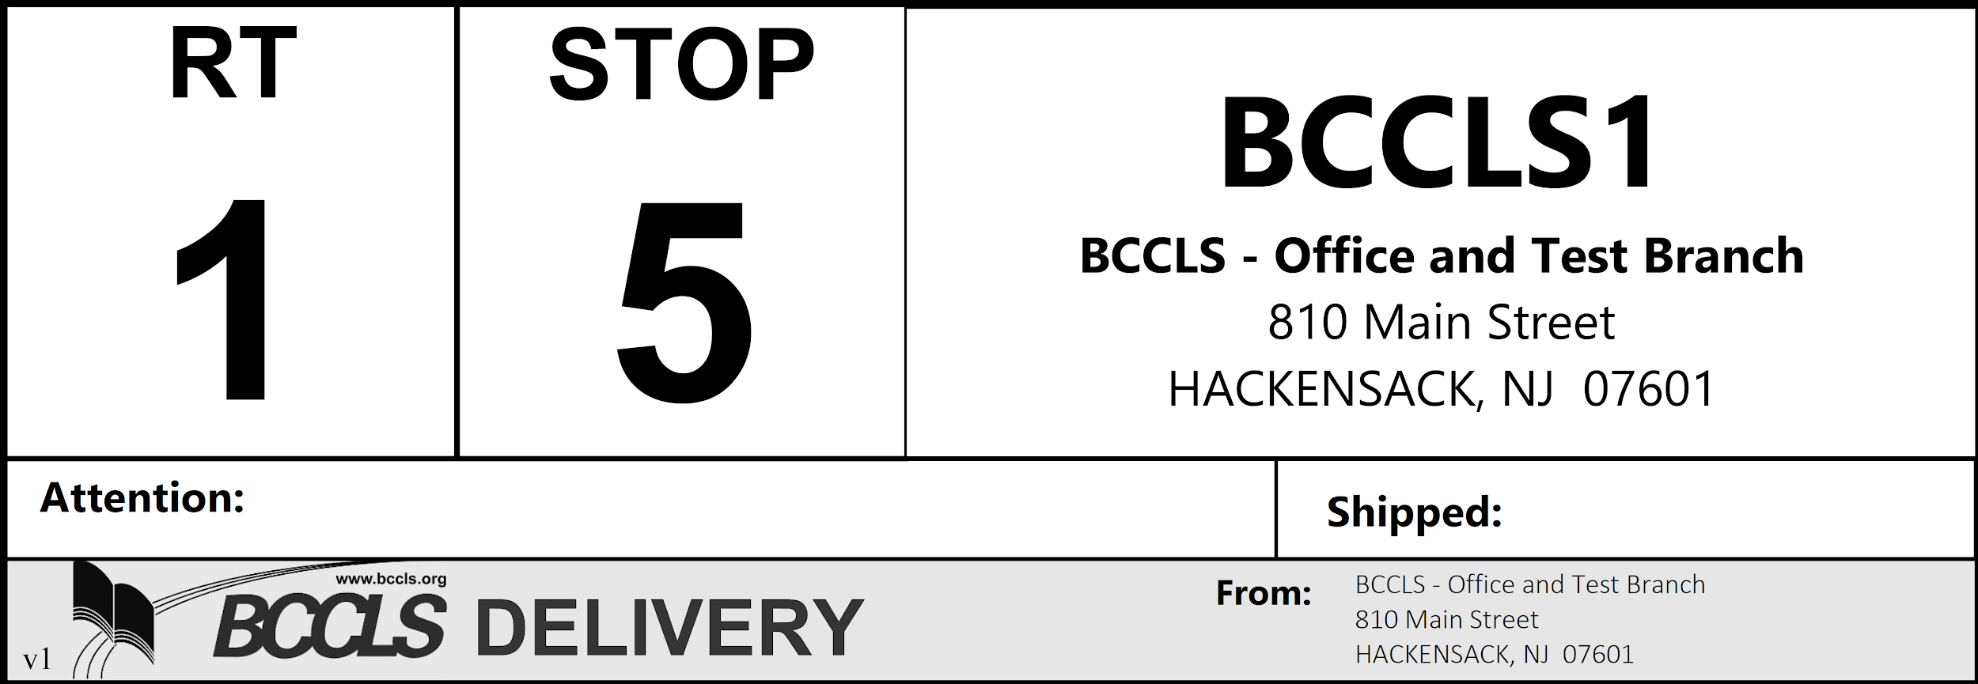BCCLS is open to offering flexibility with the format of labels in collaboration with the successful bidder.

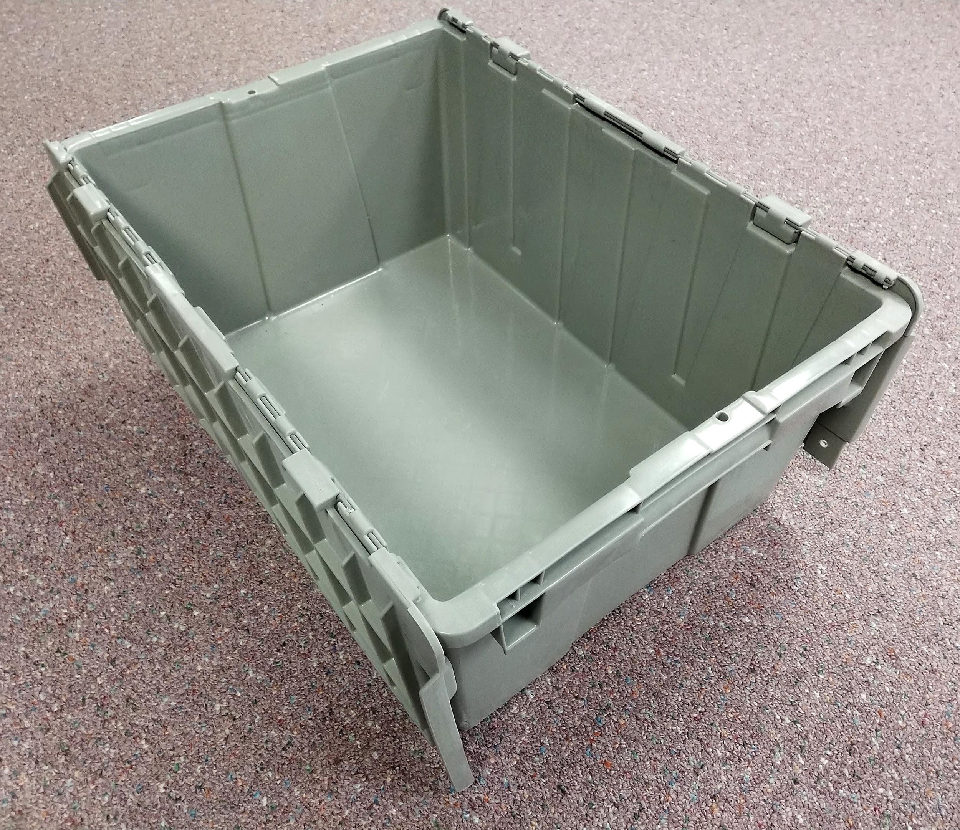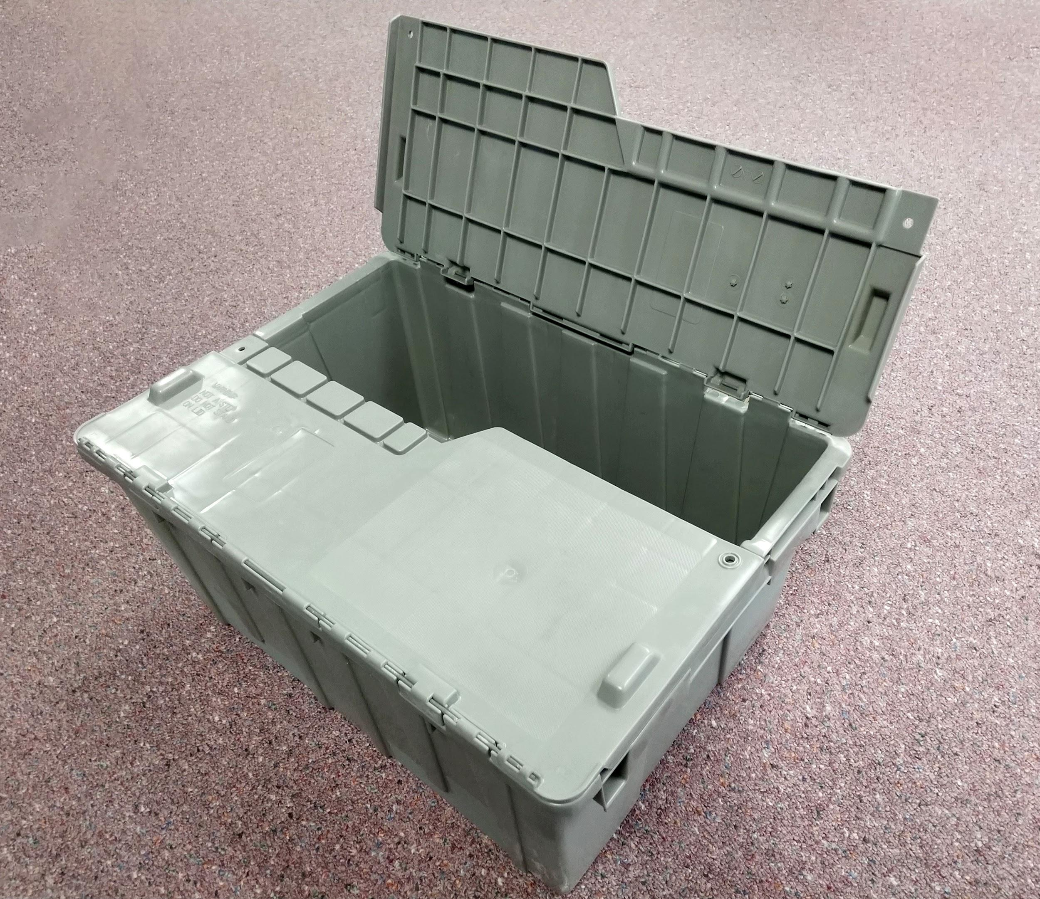

APPENDIX C - PROPOSAL RESPONSE CHECKLIST:

Bergen County Cooperative Library System
Request for Proposal for Consortium-Wide Delivery System
2018
Proposal Response Checklist - Required

The following checklist is provided as assistance to the development of the RFP Response. It in no way supersedes or replaces the requirements of the RFP.

Required: Please initial on the lines below for each document/section attesting to the fact that you have read and/or included the documents with your RFP. Return this checklist with your proposal.

Company Name: ____________________________________________________________________

Name of Person Completing the Checklist: ________________________________________________

Sections:(Initial Each Section)

1. Introduction: Background and Purpose __________
2. Scope of Work __________
3. Special Terms and Conditions __________
4. Vendor Requirements/Responsibilities __________
5. Quality Assurance and Administrative Fees __________
6. Pre-Proposal Meeting Questions __________
7. Renewal Factors __________
8. Cost Information __________
9. Bidder Submittal Requirements __________
10. Award Process __________
11. Bidder Instructions __________
12. Sealed Proposals __________
Acknowledgement of Receipt of Appendix A & B __________

Please be advised that, in addition to any other stated requirements of responses to this RFP, the failure to provide the following will be considered fatal defects in a bid that would render a bid unresponsive:
1. Proof of insurance as described in Section 9.5. __________

2. Signature as described in Section 9.14. __________

